www.doi.org/10.37785/revista.vXnX.X
Original Articles

Title in English Language
(Maximum 80 characters, Times New Roman 16, centered and bold)

Título en Español
(Máximo 80 caracteres, Times New Roman 16, centrado y en negrita)

Author’s Name¹ ^{https://orcid.org/código_orcid}, Author’s Name² ^{https://orcid.org/código_orcid}, Author’s Name ³ ^{https://orcid.org/código_orcid}

¹Afiliation, City, Country
email@email.com

²Afiliation, City, Country
email@email.com

³Afiliation, City, Country
email@email.com

Sent: year/month/day
Accepted: year/month/day
Published: year/month/day

Abstract
This page is designated for the abstract in English that must synthesize the document's content between 150 to 250 words, followed by the keywords section. Under no circumstances can the abstract go to the next page. Page two has been assigned to enter this same content in the Spanish language (Resumen) and keywords (keywords). The suggested font is Times New Roman, size 12 pt, not indented and justified. Use single spacing and do not add extra space before or after paragraphs. The abstract does not accept images, tables, formulas, or any other non-textual resource to illustrate the work. It is also not recommended to use abbreviations that have not been defined previously. The abstract will be used as a printed reference or on the journal site to indicate what is covered in the article's content. It is not recommended to use bibliographic citations in the abstract. This document is mostly edited in APA 7 format. Authors should follow the instructions, including the A4 size and format. This document is a guide to writing your article or as a template to do so.

Keywords: In this section, you must suggest the keywords of your work. Minimum five keywords separated by commas not included as part of the title text. To select the keywords, please refer to the UNESCO THESAURUS according to the article/study area as defined in the groups https://vocabularies.unesco.org/browser/thesaurus/en/groups
Summary: Introduction, Materials and Methods, Results, Discussion of Results, and Conclusions.

How to cite: Authors name (Sourname, N.) (202X). Article Tittle. Revista Tecnológica - Espol, XX(X). Recover by http://www.rte.espol.edu.ec/index.php/tecnologica/article/view/XX

Resumen
Esta página esta designada para el resumen en Español que debe sintetizar el contenido del documento y debe contener entre 150 a 250 palabras, seguido de la sección de palabras clave. En ninguna circunstancia el resumen puede pasar a la siguiente página. La página dos ha sido asignadas para ingresar este mismo contenido en idioma inglés (abstract), junto con las palabras claves (keywords). La fuente sugerida es: Times New Roman, tamaño 12 pt, sin sangría y justificado. Use interlineado sencillo y no agregue espacio adicional antes o después de los párrafos. En el resumen no se aceptan imágenes, tablas, fórmulas, o cualquier otro recurso no textual que emplee para ilustrar su trabajo. Tampoco se recomienda utilizar abreviaciones que no hayan sido definidas con anterioridad. El resumen será empleado como referencia impresa o en el sitio de la revista como una indicación de lo que se cubre en el contenido del artículo. No se recomienda usar citas bibliográficas en el resumen. Este documento está editado mayormente en el formato APA 7. Los autores deben seguir las instrucciones, incluyendo el formato y tamaño A4. Este documento es una guía para escribir su artículo o como una plantilla para hacerlo.

Palabras clave: En esta sección debe sugerir las palabras clave de su trabajo. Mínimo cinco palabras claves separadas por coma que no estén incluidas como parte del texto del título. Para seleccionar las palabras clave, recomendamos que consulte el TESAURO DE LA UNESCO en función del artículo/ámbito de estudio, tal como se define en los grupos https://vocabularies.unesco.org/browser/thesaurus/es/groups.

Introduction
The modality for receiving works for publication in the RTE-ESPOL journal is through a document in doc or docx format, which must be uploaded to the journal's digital platform located on the website http://www.rte.espol.edu.ec; this is an instruction file for Word users and can be used as a template.

Authors are recommended to check that their final submission format follows this guide. One way to verify this is by converting the file to PDF format and verifying that the titles, indents, images, and tables correspond to the norm. In addition, the authors are requested to verify every detail of the publication, including the order of the authors' names, affiliation, emails, ORCID code, and the length of the article, which should be around 5,000 to 8,000 words, not including the references. Finally, the document must be free of grammatical and semantic errors. All this must be checked before the document is sent to the organizers. You cannot update files at a post-submission stage.

The full papers will be published in a digital version with the corresponding ISBN and DOI. Please note that we do not need a printed paper version.

IMRD Structure
It is recommended that the document sections follow an IMRD structure: Introduction / Objectives, Materials and Methods / Methodology, Results / Discussion of Results, and Conclusions.

Materials and Methods
From this section, the contents of the topic are developed in an orderly and sequential manner. Each topic is organized within a section. Each section will contain a title whose style is "Level 1" (Times New Roman, 12 points, bold, centered, without number, and capital letters in each word except articles). "Materials and Methods" is an example of a level 1 title. Each title can be organized into subtitles that will have a "Level 2" style. The following is an example of level 2 subtitles.

Subtitle
Level 2 subtitles are Times New Roman font, 12 points, bold, left-aligned, and without indentation. Use the "Level 2" style of this template for that purpose.

Page Size Specification
The page size is that of a U.S.-style A4 sheet, 297 mm wide and 210 mm long.

The margins should have the following measurements in inches (centimeters: cm):

Top - Bottom = 1” (2.54 cm)
Left - Right = 1” (2.54 cm)

All studies that involve human participants or animal subjects should mention the process to obtain the documentation of ethical approval or exemption, along with any relevant details regarding participant consent and welfare.

Results and Discussion
Regarding the page style, the document's text has a Times New Roman font, 12 points, justified, with indents in the first line of the text paragraph at 0.5 inches (1.27 cm). Therefore, do not insert hyphens (manual breaks) into words at the end of the line. However, it is acceptable if your word processing program automatically inserts breaks in long hyperlinks (such as in a DOI or URL in a reference list entry). Use the RTEn style of this template for this purpose.

Typeface Font for Document
The entire document must be written using Times New Roman. Other types of fonts will be used only for special cases required, allowed within the norms of APA 7.

Document Cover
The title must be in Times New Roman font, size 16 points, centered, in bold and the style is "Heading 1". The authors' names are 12 points centered, followed by a super index that indicates the affiliation. The Orcid ID must be included at the same level as the super index (if it does not have Orcid, it must be created for each author as appropriate). The affiliation in font size 12 points, italics, centered, and finally the emails in size 11 points with Courier font.

Each word in the title must start with a capital letter, except for minor words and articles such as: "to," "from," "and," "from," among others.

Authors' details should not show any professional title such as Ph.D., MSc, Dr, Eng, etc. Expecting to avoid confusion, the full first and last names of each author must always be written.

The description of the affiliation must include at least the name of the university, school/college, or department and the country.

Section Titles and Subtitles
Section titles and subtitles are organized in three levels, as described below.

First Level (Section Title)
The first level corresponds to the section title. Times New Roman font, 12 point size, centered, bold, and all capitalized words in the first letter except for words under five letters. Use the "Level 1" style of this template for this purpose.

Second Level (Subtitle One)
A second level corresponds to the subtitle. It is used Times New Roman font, 12 point size, bold, without indentation, and aligned to the left. Use the "Level 2" style of this template for this purpose.

The third level (Subtitle Two)
A third level corresponds to a subtitle within the second level. Times New Roman font, 12 point size, without indentation, left aligned and italic. Use the “Level 3” style of this template for this purpose.

Figures and Tables
Las figuras y tablas deben estar centradas en la página. Tablas y figuras tienen la misma configuración.

Tables
All tables will be identified with the word "Table" followed by a sequential number order in which they are mentioned in the document.

Table title: the table title will appear in two lines above the current table:

Line one: table identification number. Times New Roman font, 12 point size, centered, bold, example: Table 1.

Line two: a short but descriptive title. Times New Roman font, 12 point size, centered, italic, capital letters only larger words example: "Font Sizes for Articles."

All references to tables must have a cross-reference with the current table. To verify the cross-reference, hold down the "control" key and click on Table 1; the document will take you to the current position of the table.

Column headings: All tables must include column headings. Times New Roman font size 8 to 10 points as required. Center column headings and capitalize them.

Body: The body of the table includes all the rows and columns of a table. A cell is the point of intersection between a row and a column. The body of the table can have single, one and a half, or double space or space. Times New Roman font size 8 to 10 points as required. Left aligns the information in the leftmost column or the stub column, or the body of the table.

In general, center your information on all other cells in the table. However, it can be left-align the information. Doing so would improve readability, particularly when cells contain much text.

The following table shows the application of these rules. Use the "Text Tables" style of this template for this purpose.

Table 1
Font Sizes for Articles
SIZE | ELEMENT | FONT | BOLD | ITALICS
8 | Table content  Figure titles  References to objects | Times New Roman | Yes | Yes
10 | Email addresses  Title body | Courier | No | No
12 | Author name | Times New Roman | Yes | No
16 | Article Title | Times New Roman | Yes | No
12 | Level 1 Section
11 | Level 2 Section | Times New Roman | No | No
11 | Level 3 Section | Times New Roman | No | Yes

Figures
Graphics must be in color, preferably using standard colors to be reproduced in any system. By standard colors, we mean red, blue, green, yellow. Try to avoid complex colors like light blue combined with stronger blue because they could be confused. Instead, use solid colors that stand out from the background of the figure to improve contrast.

Figure Title: The figure title will appear on two lines above the current figure:

Line one: identification number of the figure. Times New Roman font, 12 point size, centered, bold, example: Figure 1.

Line two: a short but descriptive title. Times New Roman font, 12 point size, centered, italic, capital letters only major words example: " Field Trial Schedule."

Image: The image part of the figure is the graph, chart, photograph, drawing, or other illustration itself. If the text appears in the image of the figure (for example, axis labels), use Sans Serif with a font between 8 and 14 points.

Caption - A figure legend, or key, if present, should be placed within the edges of the figure and explains the symbols used in the figure image. Capitalize the words in the caption of the figure

.
Figure 1
Field Trial Schedule
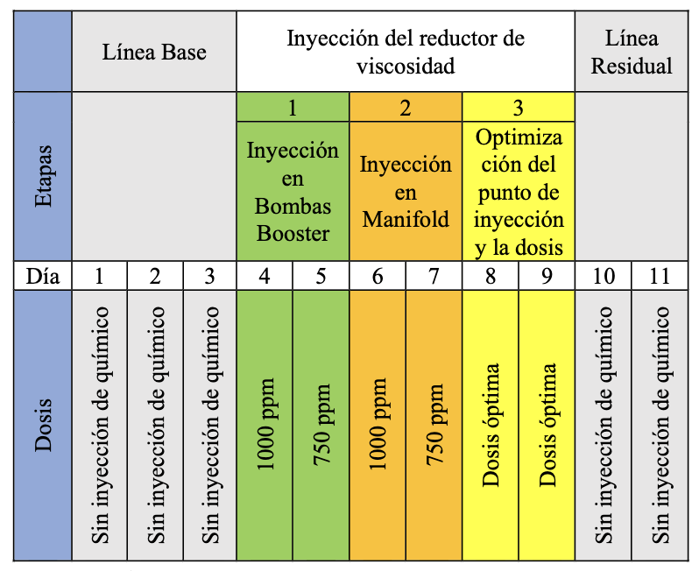
Note: Three types of notes (general, specific, and probability) may appear below the figure to describe the contents of the figure that cannot be understood from the figure's title, image, or legend alone (for example, abbreviation definitions, copyright attribution), explanations of asterisks are used to indicate values. Include figure notes only as needed.

Figure 2 is an example of an image imported into the document. In these cases, be sure to use the appropriate resolution so that the figure can be seen clearly in the document.

Do not use low-resolution figures because it impoverishes the quality of the article. Instead, when inserting a shape, be sure to check the following:

• Colors contrast adequately.
• The image is clear.
• Any text on the image can be read.

Figure 2 shows a case where the resolution is inadequate, while Figure 3 shows a better adaptation of the same figure.

Figure 2
Example of low-Resolution Figure
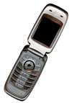

Figure 3
Example of high-Resolution Figure

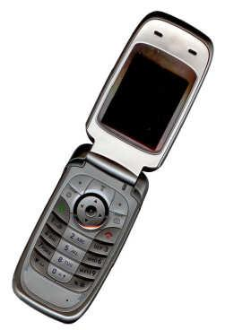

Use a cross-reference to link to each figure or table, for example. For example, click on the following text, "Figure 2", this word will become shaded; press control + click to go to the image.

Page Numbers, Headers, and Footers
The author should not change these three elements.

Hyperlinks and Shortcuts
Any hyperlinks or references to the Internet must be written in their entirety. That is, write the full URL of the resource location instead of leaving shortcuts. References are written using a regular font like the rest of the article.

Citations and Bibliographic References
In the case of citations, if you mention a bibliographic reference in the body of the article, use only the parentheses according to APA 7 regulations. For example, never use terms such as "see reference (Author, 2021)", instead use "see Author (2021) ”. If there are several references together, separate them with a semicolon. In general, you must follow all the rules outlined in APA 7 for all subpoenas cases.

The examples listed in the references section of this document include the following citations depending on the literary source:

- example from a book (Jackson, 2019)
- example of a book part of a series (Dillard, 2020)
- example from another magazine article (Lyons, 2009)
- example of a conference paper (Evans et al., 2019)
- example of a website (World Health Organization, 2018)
- example of a website page (U.S. Census Bureau, n.d.)
- example of a data sheet (Agency for Toxic Substances and Disease Registry, n.d.)
- example of a thesis (Kabir, 2016)
- example of a technical report (Stuster et al., 2018)
- example of a journal (Grady et al., 2019)

In the case of references: the heading of the references section must follow the rules of the "document title."

The way of referencing can change according to the type of literary source. The references follow the APA 7 standard, and the text size is 10 points, aligned to the left, without leading and trailing spacing. French indentation at 0.5 inches (1.27 cm)

Conclusions
The purpose of this section is to summarize the main results discussed throughout the article. Remember to handle the conclusions as short statements based on the theory and the stated objectives. This section has no special formatting requirements.

Acknowledgments and Declarations
This section follows the regular format of the rest of the document highlighting acknowledgments to organizations or individuals who have contributed or funded to developing the research presented in the article. If not stated, it is assumed the study did not receive any fund or it does not need to be declared. Thus, it is indicated, for example:

This work has been partially funded by Research Project XXXX and is part of Thesis XXX. The authors wish to express their gratitude to XXX's participation in the work and the XXX Center.

Please declare in this section, individual authors´ contributions clearly in a dedicated section. Failure to declare individual contributions will imply equal contribution from all authors.

For articles with more than one author, following the authorship criteria under the CRedit taxonomy (https://credit.niso.org/), please declare the individual contributions of the authors. No declaration of individual contributions will imply equal participation of all authors.

Depending on the case, authors must include one of the following statements on the use of AI:
Case 1. No use of AI
“The author(s) declare(s) that no artificial intelligence tools have been used for the preparation of this article”.

Case 2. Use of AI
“The author(s) declare(s) that, in the preparation of this article, AI tools (specify the name of the AI and its version) were used………… for the purpose of ……….(specify which tasks were performed with the support of AI and in which sections of the article).”

References
Jackson, L. M. (2019). The psychology of prejudice: From attitudes to social action (2nd ed.). American Psychological Association. https://doi.org/10.1037/0000168-000
Dillard, J. P. (2020). Currents in the study of persuasion. In M. B. Oliver, A. A. Raney, & J. Bryant (Eds.), Media effects: Advances in theory and research (4th ed., pp. 115–129). Routledge.
Lyons, D. (2009, June 15). Do not ‘iTunes us: It is geeks versus writers. Guess who is winning. Newsweek, 153(24), 27.
Evans, A. C., Jr., Garbarino, J., Bocanegra, E., Kinscherff, R. T., & Márquez-Greene, N. (2019, August 8–11). Gun violence: An event on the power of community [Conference presentation]. APA 2019 Convention, Chicago, IL, United States. https://convention.apa.org/2019-video
World Health Organization. (2018, May 24). The top 10 causes of death. https://www.who.int/news-room/fact-sheets/detail/the-top-10-causes-of-death
U.S. Census Bureau. (n.d.). The U.S. and world population clock. U.S. Department of Commerce. Retrieved January 9, 2020, from https://www.census.gov/popclock/
Agency for Toxic Substances and Disease Registry. (n.d.). Asbestos in your environment: What you can do to limit exposure [Fact sheet]. U.S. Department of Health & Human Services. https://www.atsdr.cdc.gov/docs/limitingenvironmentalexposures_factsheet-508.pdf
Kabir, J. M. (2016). Factors influencing customer satisfaction at a fast-food hamburger chain: The relationship between customer satisfaction and customer loyalty (Publication No. 10169573) [Doctoral dissertation, Wilmington University]. ProQuest Dissertations & Theses Global.
Stuster, J., Adolf, J., Byrne, V., & Greene, M. (2018). Human exploration of Mars: Preliminary lists of crew tasks (Report No. NASA/CR-2018-220043). National Aeronautics and Space Administration. https://ntrs.nasa.gov/archive/nasa/casi.ntrs.nasa.gov/20190001401.pdf
Grady, J. S., Her, M., Moreno, G., Perez, C., & Yelinek, J. (2019). Emotions in storybooks: A comparison of storybooks that represent ethnic and racial groups in the United States. Psychology of Popular Media Culture, 8(3), 207–217. https://doi.org/10.1037/ppm0000185

